**How to Update the Image Slider**

This article can be used to provide a step by step instructions on how to add / modify or remove images from the slider, how to change the characteristics, and where to locate the documentation. The image slider is a free plugin.

**Image Slider Source**

The image slider is a responsive jQuery content slider, sourced from bxSlider created Steven Wanderski a Chicago Web Developer. This slider is free to use as used in this website, and used the Manual Installation method as documented in the [Install](https://bxslider.com/install/) Section of the developer’s website.

bxSlider – bxSlider.com

The jquery.bxslider files are saved in the following folders:

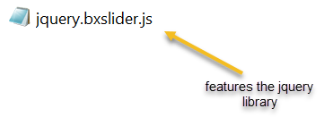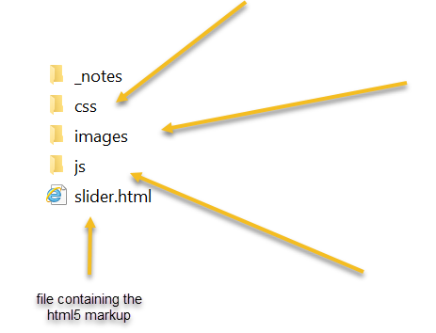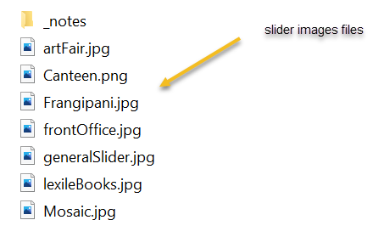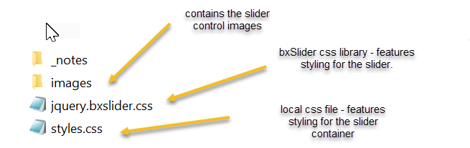

**Preparing Images**

Image Types: The slider can accept .PNG and .JPG files. The preference is .JPG as they can be compressed down to a smaller size. The .PNG format can be used where transparency is required or for logos.

Image Size: 1000px by 300px at 72 dots per inch (dpi). It is important to try to keep the aspect ratio (10:3) of the slider container. The settings of the slider will scale the image to fit the area if the image is not exact. Be aware that cropping will occur if the aspect ratio is not maintained.

Using the photo editor of your choice save the image in the images folder with a brief, meaningful name. If the image name is two words then use camel case naming convention. e.g. artFair.jpg

**Adding images to the image slider**

To add a new image to the image slider carousel, follow these steps

1. Open the html file called slider.html located in the root directory.
2. Once open insert the following line of code substituting the details of the image you are inserting. Place the line of code in the position you want the image to appear in the slider. For example, if you want the slider to be the first image, then insert the code at the start.
3. Save the changes and upload the file to the website.

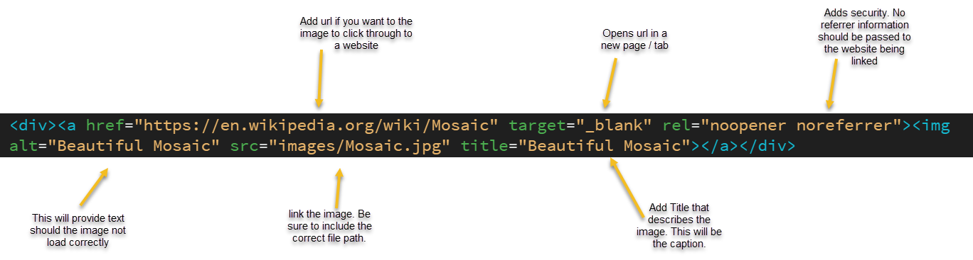

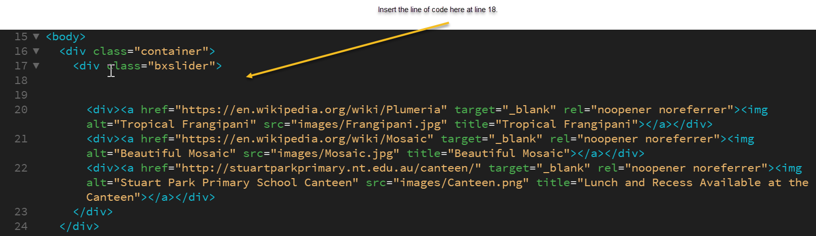

**Deleting images from the image slider**

1. To delete an image. Open the file slider.html. Highlight the whole line of code relating to the image and press delete.
2. 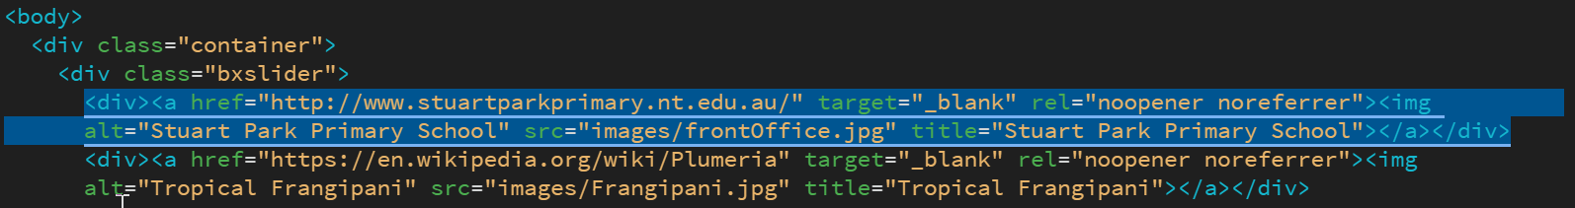Save the changes and upload the file to the website.

**Modifying the image slide**

To modify the slider review the documentation located [bxslider.com - options](https://github.com/stevenwanderski/bxslider-4) or follow the link to [Github](https://github.com/stevenwanderski/bxslider-4) where you will find more information and feedback from the developer and other users. Stack Overflow is also a good resource. The following code is located in the JS file myScript.js. This sets how the slider will function. There are a range of options for this slider that can be changed.

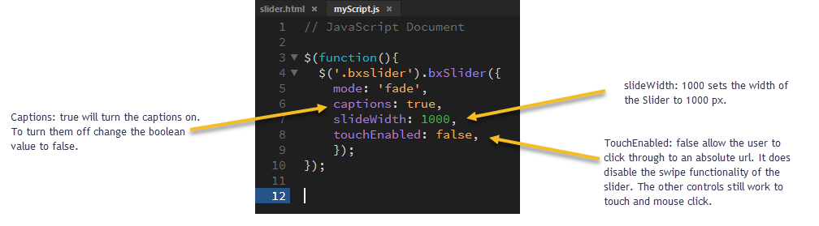

|  |  |  |  |
| --- | --- | --- | --- |
| **DOCUMENT VERSION INFORMATION** | | | |
| **Date Approved** | **Version** | **Brief Description** | **Approved By** |
| 19/06/2021 | 1.0 | How to update the images slider. | Ingrid Barry |

Write up documentation in a business format for a junior web developer to update and add images to your image slider created in Task 4.

You are to include references to where you obtained the original library from, links to the library’s official documentation and a step by step instruction sheet on how to add / modify or remove images from the slider.

This step by step instruction sheet is to include information like, images side, resolution, file location and specifics on how to modify your code to incorporate the changes.

This document is to be included in a folder called ‘task 5’.